**Project 2**

**Filters: High-pass, Low-pass, Band-pass, and Notch**

**INTRODUCTION:**

This laboratory studies the use of passive components to create filters to separate portions of time-dependent waveforms. Filters are an essential tool in our complex world of mixed signals — both electronic and otherwise. Passive components (resistors, capacitors, and inductors) have long served as filter components for everything from selecting radio stations to filtering out electrical noise.

**OBJECTIVES:**

1. Learn the four general filter types: High-pass, Low-pass, Band-pass, and Notch
2. Learn to alter filter type by changing contacts for output voltage.
3. Learn phase angle at cutoff for simple RC and RL filters.
4. Learn to draw Bode Plots.

**Equipment:**

1. Function generator
2. Oscilloscope
3. Digital Multimeter

**Components:**

1. Resistors: 10kΩ, 100 Ω
2. Inductor: 100mH
3. Capacitor: 0.005 µF, 0.01 µF

**BACKGROUND**

In many circuits, a wide range of different frequencies are present, some of which are desired, while others are not. The frequency response of capacitors and inductors allows us to construct filters that will pass or reject certain ranges of the electrical frequencies that are applied to them.

"Passive filters" created from “passive” components (inductors, capacitors, and resistors) have served us well for a long time for such purposes as selecting radio and television stations and filtering noise out of various signals. Indeed, much of the electronics we take for granted today would not be possible without the use of such filters.

The four typical types of filter behaviors are illustrated in Figure 1, along with schematics of simple filters that exhibit the indicated behavior.

**Types of Filters**

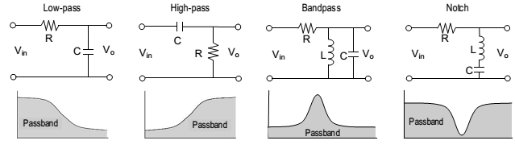

**Figure 1**

The filter types are low-pass, high-pass, band-pass, and notch (or band-reject) filters. In Figure 1, the grayed area is the pass-band, that is, the part of the signal that is passed to the output of the filter. The rejected portions are called the stop-band. The frequency that separates the pass-band from the stop-band is called the cutoff frequency. The cutoff frequency is equivalent to the half-power points. The cutoff frequency is also sometimes called the corner frequency.

A low-pass filter would allow extracting a low frequency, such as an audio signal, that is mixed with a high frequency radio wave. A high-pass filter would do the opposite. A resonant circuit can be tuned as a band-pass filter to retain signals in a narrow range of frequencies, while rejecting frequencies outside that range. Such is the case with a radio tuner. A notch filter generally keeps all frequencies except those in a narrow band. Notch filters are widely used to block interfering signals from noise sources. Band-pass and notch filters require resonant circuits.

Notice that the components making the low-pass and high-pass filters in Figure 1 are the same. Whether the circuit is low-pass or high-pass depends only upon which voltage we look at: the voltage across the capacitor or the voltage across the resistor. (Equivalent circuits could have been made using an inductor and a resistor.) Similarly, the notch filter is identical to the RLC series resonant circuit. RC and RL filters are simple, inexpensive, and often used effectively as filters. Their major problem is their generally slow (in frequency) transition from pass-band to stop-band. The addition of a few simple components in filter “stages” can increase the transition rate, giving the filter a sharper cutoff. The ratio of an output response to an input signal is referred to as a transfer function. The input signal and the output response do not need to be the same entity type. For example, a transfer function may prescribe an output voltage resulting from an input current. Transfer functions are often used as a tool to characterize the effect of a filter regardless of the details of the filter’s structure. It can make the analysis of complex circuits easier. In this lab, however, we will mostly be studying the filter itself.

**Cutoff Frequency for series RC and RL circuits**

As mentioned, the cutoff frequency, sometimes called the corner frequency, is equivalent to the half-power points. Since the power is half that at the peak, the voltage (or current) will be the peak voltage (or current) multiplied by 1/√2 = 0.707. For a simple 2-component RC or RL circuit, the half-power point will occur when half the power is dropped on the resistor and half on the capacitor or inductor. Thus, the cutoff frequency will occur when the reactance of the capacitor or inductor equals the total series resistance in the circuit. That is, $X_{C}=\frac{1}{2πf_{c}C}=R$ and $X_{L}=2πf_{c}L$ = R and so,

$$f_{c=1/{2πRC}}$$

and $$f_{c=R/{2πL}}$$

**decibels (dB)**

As discussed in your textbook, the decibel (dB) is commonly used for the magnitude of voltages

and currents in making Bode plots. Keep in mind that a decibel is a unit created to measure the

transfer function for power gain (or loss) through a circuit module or stage:

$$Number of decibels=10 \log_{10}\left[\frac{power output}{power input}\right]$$

Since power is proportional to the square of the voltage or the current, we have equivalently,

$Number of decibels=20 \log_{10}\left[\frac{V_{out}}{V_{in}}\right]$ and $Number of decibels=20 \log_{10}\left[\frac{I_{out}}{I_{in}}\right]$

**Procedure:**

**Low-pass filter.**

1. Obtain a 10kΩ resistor and a 0.005 µF capacitor. Measure and record the actual values of the components.
2. Using the measured components, set up the circuit as shown in Figure 2. Use the function generator FGEN for the supply voltage.

**Low Pass Filter**

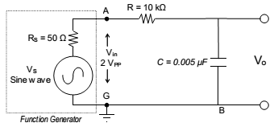 **Figure 2**

1. Calculate the cutoff frequency for the circuit, assuming the output is at Vo. At the Cutoff frequency, what, theoretically, will be the voltage V0?
2. Connect CHANNEL 1 of the oscilloscope to measure the Vin (i.e., FGEN).
3. Connect CHANNEL 2 of the oscilloscope to measure the filter’s output voltage Vo. Vary the frequency from 500 Hz to 10 kHz in steps indicated in Table 1, and record the indicated values.
4. Measure the phase shift Δt and then calculate the phase angle φ between Vin and Vo at 500 Hz, at 10000 Hz, and at the cutoff frequency.
5. Using the data of Table 1, sketch a Bode plot of the of the filter’s output voltage.

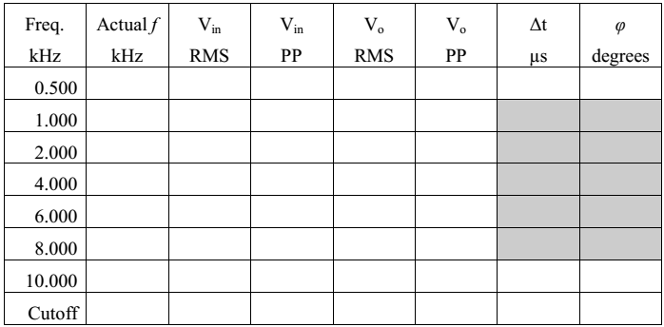

**Table 1**

**Band-Pass Filter**

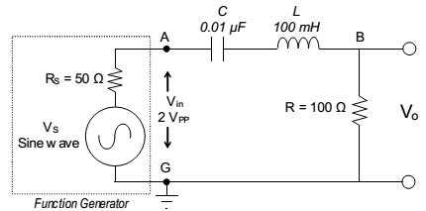

**Figure 3**

1. Set up the series RLC circuit shown in Figure 3, using the function generator to provide the sinusoidal input voltage.
2. Calculate the resonant frequency f0 of the circuit. (See Laboratory 9.)
3. Set the “peak amplitude” to 1.0 V (that is, 2.0 VPP).
4. What is the measured resonant frequency? ____________
5. What is the measured bandwidth? __________________
6. What is the phase angle at resonance? _______________
7. What is the phase angle at the two cutoff frequencies?__________________
8. Sketch the Magnitude and Phase angle Bode plots, marking key reference points.

**Notch Filter**

1. Switch the positions of the resistor with inductor and capacitor to get the series RLC circuit shown in Figure 4.

**Notch Filter**

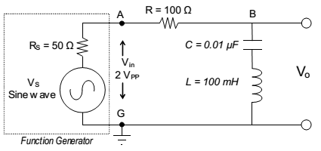

**Figure 4**

1. Calculate the resonant frequency f0 of the circuit.______________________
2. What is the measured resonant frequency fc? ________________
3. What are the lower and upper half-power points, f1 _______and f2?___________
4. What is the measured bandwidth? ______________
5. What is the phase angle φ at resonance?____________________
6. Draw the Bode plot.